Retrieval-Augmented Generation with Knowledge Graphs for
Customer Service Question Answering v1
Note: Method has been deployed within LinkedIn’s customer service

Problem statement: To track customer’s ticket issue and response based on the past issue history using intra-issue and inter issues relationship.

Approaches (Figure1 ):

Step1: Find intra-team entity, relationship based on historical issue tickets and generate a tree(subgraph)
Step2: Using subgraph (trees) design KG with inter-issue ticket entity relation.
Step3: Retrieval: During the question-answering phase, the method parses consumer queries and retrieves related sub-graphs from the KG to generate answers. which stores the embedding in the vector DB.

“This integration of a KG not only improves retrieval accuracy by preserving customer service structure information but also enhances answering quality by mitigating the effects of text segmentation with fix size.”

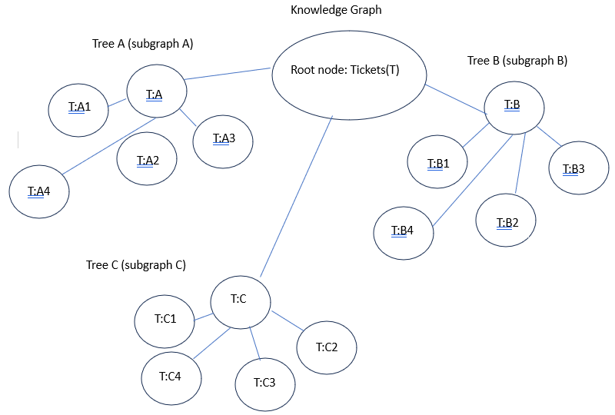

Figure 1: Knowledge Graph DB structure for customer issue tickets
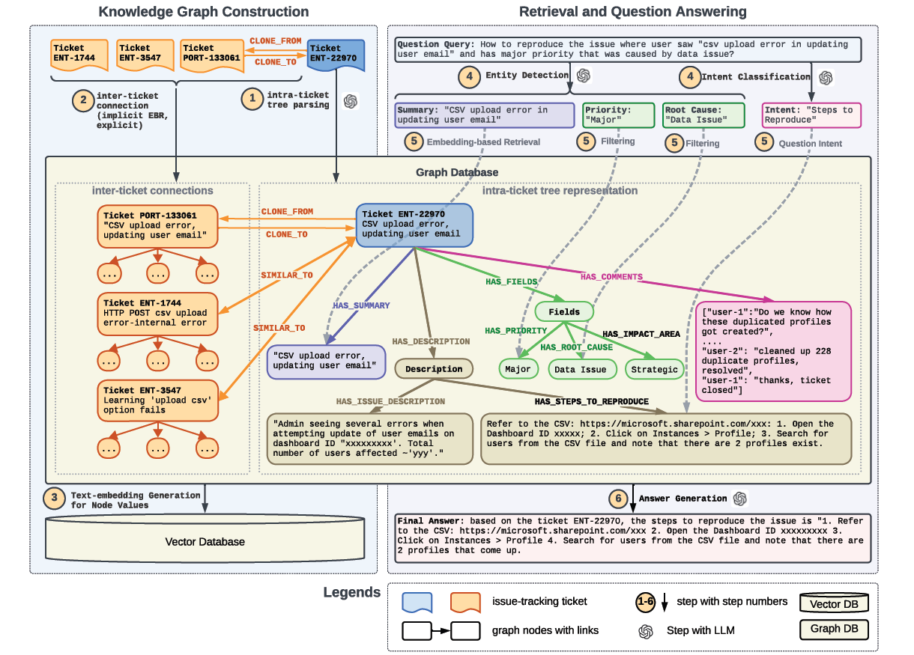
Figure 1: An overview of our proposed retrieval-augmented generation with knowledge graph framework. The left side of this
diagram illustrates the knowledge graph construction; the right side shows the retrieval and question answering process.

CONCLUSIONS AND FUTUREWORK

The research significantly advances automated question answering systems for customer service based on historical data. Integrating retrieval augmented generation (RAG) with a knowledge graph (KG) has improved retrieval and answering metrics, and overall service effectiveness. Future work will focus on developing an automated mechanism for extracting graph templates, enhancing system adaptability; investigating dynamic updates to the knowledge graph based on user queries to improve real-time responsiveness; and exploring the system’s applicability in other contexts beyond customer.

